Diane Phan

October 24, 2017

ART 22

Assignment #3: Interactive Patterns, due 10/24

**Put a link or a picture of the pattern you picked or designed**

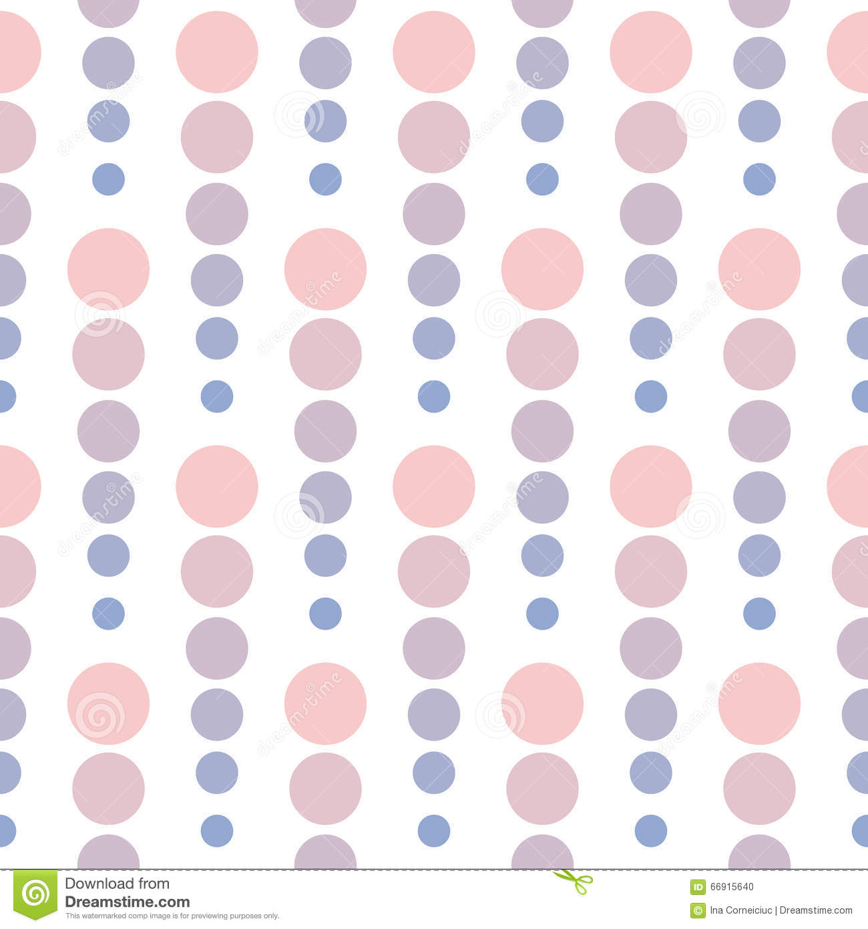

**Explain very briefly why you picked it**

I really like circles because they are nice and simple, they remind me of bubbles or unique beads. I thought the color scheme in this picture brought out the uniqueness of the circle pattern. I appreciate the aesthetic of having circles with decreasing radii placed next to each other, and I wanted to try doing that myself.

**What was your strategy/process in coding it**

I started by coding the first part of the pattern that I wanted to repeat. I made the first circle at the top left corner and set variables for that circle so that I could use it throughout the assignment. The variables would be used to set the coordinates for the circles that followed in the column. I did the same process for the orange circles that were upside down, which was pretty much the same method, but reversed by adding to the y values instead of subtracting. Furthermore, once I got my first designs down, I threw the code into a nested for loop so that the image could copy across the screen at varying heights. The process of creating the nested loop was that I knew that every time I moved to the right, the ellipse would move over the x-axis by 200 pixels, as well as vertically according to the value I added or subtracted to it. Lastly, I wanted to include the title of my piece at the bottom and have that interact with the mouse cursor as well. I used the map function to start the range in the black side on the left, where the background is darker, to represent the deep, darker end of the ocean, to move to the right side where it’s lighter.

**What are the things you have tried and which ones failed and which ones were successful? And why do you think that was the case?**

I tried very hard to get the circles to change colors according to the coordinates of mouseX. After some experimenting, I realized that I was only able to change the circles colors if I created circles that followed my cursor, meaning wherever I move, mouseX will generate a different color to fill that new circle, not the circles that I had already drawn. Eventually, I just gave the circles their own color and had the colors interact with the changing background, which responded to the mouse coordinates. I also wanted to change the stroke colors of the circles as the mouse moved along the screen, however, they would not change because I had drawn the circles in set up. If I had moved the circles to the draw function, the stroke of the circle may have been able to change as well. However, I tried that, and it did not come out how I wanted it to be, so I just deleted the code to change the stroke.

**What did you learn in the process?**

I learned how to use the map function in accordance to the cursor. It has been difficult for me to understand how to use it, so this assignment gave me more practice. I had to identify the proper range that I wanted my background to be because I did not want the background to get too dark that the circles disappear. However, I wanted to use darker shades of purple and red for this piece because this piece was inspired by octopi. (Notice how there are 8 copies of the blue circle pattern as well as the orange circle pattern. I made 8 specifically to resemble octopus legs) I had to play around with the color scheme and map it properly so that the colors would change in accordance to the mouse’s X coordinate. All in all, the map function is a difficult function to understand, however, it is useful when it comes to changing backgrounds in a unique and aesthetically pleasing manner.